Experiment No. 7

Binary Classification using Logistic Regression

Experiment No. 7.1
Binary Classification using Logistic Regression

1. Aim

To implement a binary classification model using Logistic Regression and evaluate its performance using classification metrics.

2. Objectives
To understand the concept of classification in machine learning.
To study the Logistic Regression algorithm.
To implement binary classification using logistic regression.
To evaluate the model using accuracy, confusion matrix, precision, recall, and F1-score.

3. Software Required
Python 3.x
Jupyter Notebook / Google Colab / Anaconda
Pandas Library
NumPy Library
Scikit-learn Library
Matplotlib Library

4. Introduction

Classification is a supervised learning technique used when the output variable belongs to categories or classes instead of continuous values.

Examples of classification problems include:
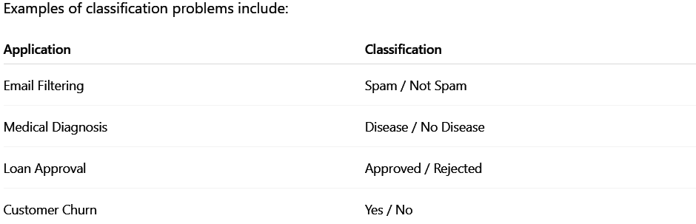

Logistic Regression is one of the most commonly used algorithms for classification problems. It predicts probabilities using the sigmoid function.

5. Sigmoid Function
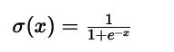
The sigmoid function converts values into probabilities between 0 and 1.

Probability ≥ 0.5 → Class 1
Probability < 0.5 → Class 0

6. Dataset Description
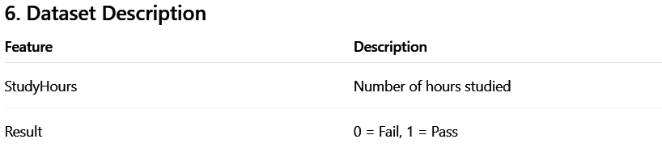

The model predicts whether a student will pass or fail based on study hours.

7. Steps in Building Logistic Regression Model
Import required libraries
Load the dataset
Split the dataset into training and testing sets
Train the logistic regression model
Predict output values
Evaluate model performance

8. Program:
1)Simple Logistical Regression Example
import numpy as np
from sklearn.linear_model import LogisticRegression
X = np.array([
[22, 20000],
[25, 22000],
[47, 49000],
[52, 60000],
[46, 52000],
[56, 65000],
[48, 58000],
[30, 30000],
[28, 27000],
[40, 50000]
])

y = np.array([0, 0, 1, 1, 1, 1, 1, 0, 0, 1])
model = LogisticRegression()
model.fit(X, y)

sample = np.array([[35, 40000]])
prediction = model.predict(sample)
print("Prediction (0 = No, 1 = Yes):", prediction)
prob = model.predict_proba(sample)
print("Probability:", prob)
Output:
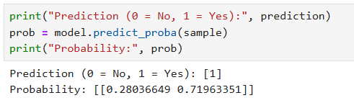
2) Case Study for Logistical Regression
import pandas as pd
dataset = pd.read_csv('Social_Network_Ads.csv')
X = dataset[['Gender', 'Age', 'EstimatedSalary']]
y = dataset['Purchased']
from sklearn.model_selection import train_test_split
x_train, x_test, y_train, y_test = train_test_split(
X,
y,
test_size=0.25,
random_state=0
)

from sklearn.compose import ColumnTransformer
from sklearn.preprocessing import OneHotEncoder, StandardScaler

ct = ColumnTransformer(
transformers=[
('cat', OneHotEncoder(drop='first'), ['Gender']),
('num', StandardScaler(), ['Age', 'EstimatedSalary'])
]
)

x_train = ct.fit_transform(x_train)
x_test = ct.transform(x_test)
from sklearn.linear_model import LogisticRegression
model = LogisticRegression(max_iter=200)

model.fit(x_train, y_train)
y_pred = model.predict(x_test)
from sklearn.metrics import (
confusion_matrix,
accuracy_score,
precision_score,
recall_score,
f1_score
)
cm = confusion_matrix(y_test, y_pred)

accuracy = accuracy_score(y_test, y_pred)
precision = precision_score(y_test, y_pred)
recall = recall_score(y_test, y_pred)
f1 = f1_score(y_test, y_pred)

print("Confusion Matrix:\n", cm)
print("Accuracy:", round(accuracy, 2))
print("Precision:", round(precision, 2))
print("Recall:", round(recall, 2))
print("F1 Score:", round(f1, 2))

9. Output
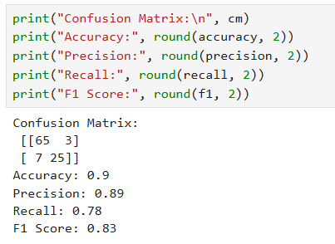

10. Result

The logistic regression model successfully predicted whether a student would pass or fail based on study hours.

11. Conclusion

Logistic Regression is a simple and effective algorithm for binary classification problems. It predicts probabilities using the sigmoid function and is widely used in real-world applications.

12. Viva Questions & Answers
1. What is classification in machine learning?
Classification is a supervised learning technique used to predict categories or classes.

2. What is Logistic Regression?
It is a classification algorithm used to predict binary outcomes.

3. Why is Logistic Regression used for classification?
Because it predicts probabilities between 0 and 1 using the sigmoid function.

4. What is the sigmoid function?
A mathematical function used to convert values into probabilities.

5. What is binary classification?
A classification problem with only two output classes.

6. Difference between Linear Regression and Logistic Regression?
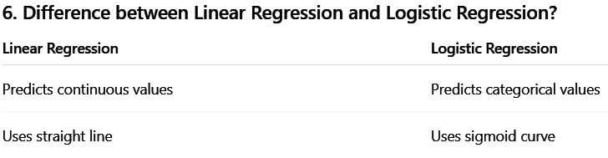
7. What is a confusion matrix?
A table used to evaluate classification performance.

8. What are precision and recall?
Precision: Correct positive predictions
Recall: Ability to identify positive cases

9. What is F1-score?
The harmonic mean of precision and recall.

10. What is the role of threshold in classification?
It decides class prediction based on probability.

Experiment No. 7.2
Case Study: Customer Purchase Prediction using Logistic Regression

1. Aim
To implement Logistic Regression on a real-world dataset and evaluate the model using classification performance metrics.

2. Objectives
- To understand real-world applications of Logistic Regression
- To preprocess categorical and numerical data
- To build a classification model using Logistic Regression
- To evaluate model performance
- To interpret results in business context

3. Software Required
- Python 3.x
- Jupyter Notebook / Google Colab / Anaconda
- Pandas Library
- NumPy Library
- Scikit-learn Library

4. Introduction
Logistic Regression is widely used in healthcare, finance, and marketing.
This case study predicts whether a customer will purchase a product based on:
- Gender
- Age
- Estimated Salary
This helps businesses target potential customers effectively.

5. Logistic Regression Model
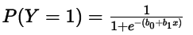
- Probability ≥ 0.5 → Purchased (1)
- Probability < 0.5 → Not Purchased (0)

6. Steps in Building the Model
- Import libraries
- Load dataset
- Separate features and target variable
- Train-test split
- Apply preprocessing
- Train model
- Predict results
- Evaluate performance

7. Dataset Description
Attribute | Description
Gender | Male / Female
Age | Customer age
EstimatedSalary | Annual salary
Purchased | 0 = No, 1 = Yes

8. Dataset Characteristics
- Type of problem: Binary Classification
- Input features: 3
- Output variable: Purchased
- Dataset type: Real-world dataset

9. Learning Objective
The model learns patterns in customer demographics and predicts purchasing behavior.

10. Program
import pandas as pd

# Load dataset
dataset = pd.read_csv('Social_Network_Ads.csv')

print(dataset.info())
print(dataset.sample(10))

# Features and target
X = dataset[['Gender', 'Age', 'EstimatedSalary']]
y = dataset['Purchased']

# Train-test split
from sklearn.model_selection import train_test_split

X_train, X_test, y_train, y_test = train_test_split(
X, y, test_size=0.25, random_state=0
)

# Preprocessing
from sklearn.compose import ColumnTransformer
from sklearn.preprocessing import OneHotEncoder, StandardScaler

ct = ColumnTransformer(
transformers=[
('cat', OneHotEncoder(drop='first'), ['Gender']),
('num', StandardScaler(), ['Age', 'EstimatedSalary'])
])

# Apply transformation
X_train = ct.fit_transform(X_train)
X_test = ct.transform(X_test)

# Model
from sklearn.linear_model import LogisticRegression

model = LogisticRegression(max_iter=200)

# Train model
model.fit(X_train, y_train)

# Prediction
y_pred = model.predict(X_test)

# Evaluation
from sklearn.metrics import confusion_matrix, accuracy_score
from sklearn.metrics import precision_score, recall_score, f1_score

cm = confusion_matrix(y_test, y_pred)

accuracy = accuracy_score(y_test, y_pred)
precision = precision_score(y_test, y_pred)
recall = recall_score(y_test, y_pred)
f1 = f1_score(y_test, y_pred)

# Print results
print("Confusion Matrix:\n", cm)
print("Accuracy:", round(accuracy, 2))
print("Precision:", round(precision, 2))
print("Recall:", round(recall, 2))
print("F1 Score:", round(f1, 2))

11. Output

Dataset information displayed
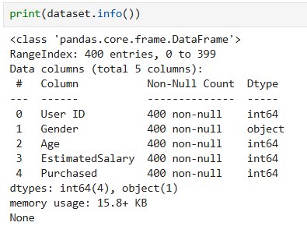
Confusion matrix displayed
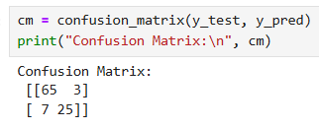
Accuracy, Precision, Recall, and F1-score printed
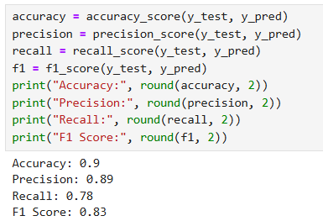

12. Conclusion
This case study demonstrates how Logistic Regression can be applied to real-world datasets. By preprocessing data and evaluating with multiple metrics, the model provides useful business insights for identifying potential customers.

13. Viva Questions & Answers

1. What is Logistic Regression used for?
It is used for binary classification problems.

2. Why is preprocessing required?
To convert data into suitable numerical format for machine learning.

3. What is One-Hot Encoding?
A method used to convert categorical data into numerical form.

4. Why is feature scaling important?
It improves model performance and training speed.

5. What is a confusion matrix?
A table showing correct and incorrect predictions.

6. What are accuracy, precision, recall, and F1-score?
These are evaluation metrics for classification models.

7. What is the role of train-test split?
To evaluate model performance on unseen data.

8. What is class imbalance?
When one class has significantly more samples than another.

9. Why is Logistic Regression suitable for this problem?
Because the output contains two classes: Purchased or Not Purchased.

10. How can this model help in marketing decisions?
It helps businesses identify customers likely to purchase products.

